**Character Controls**

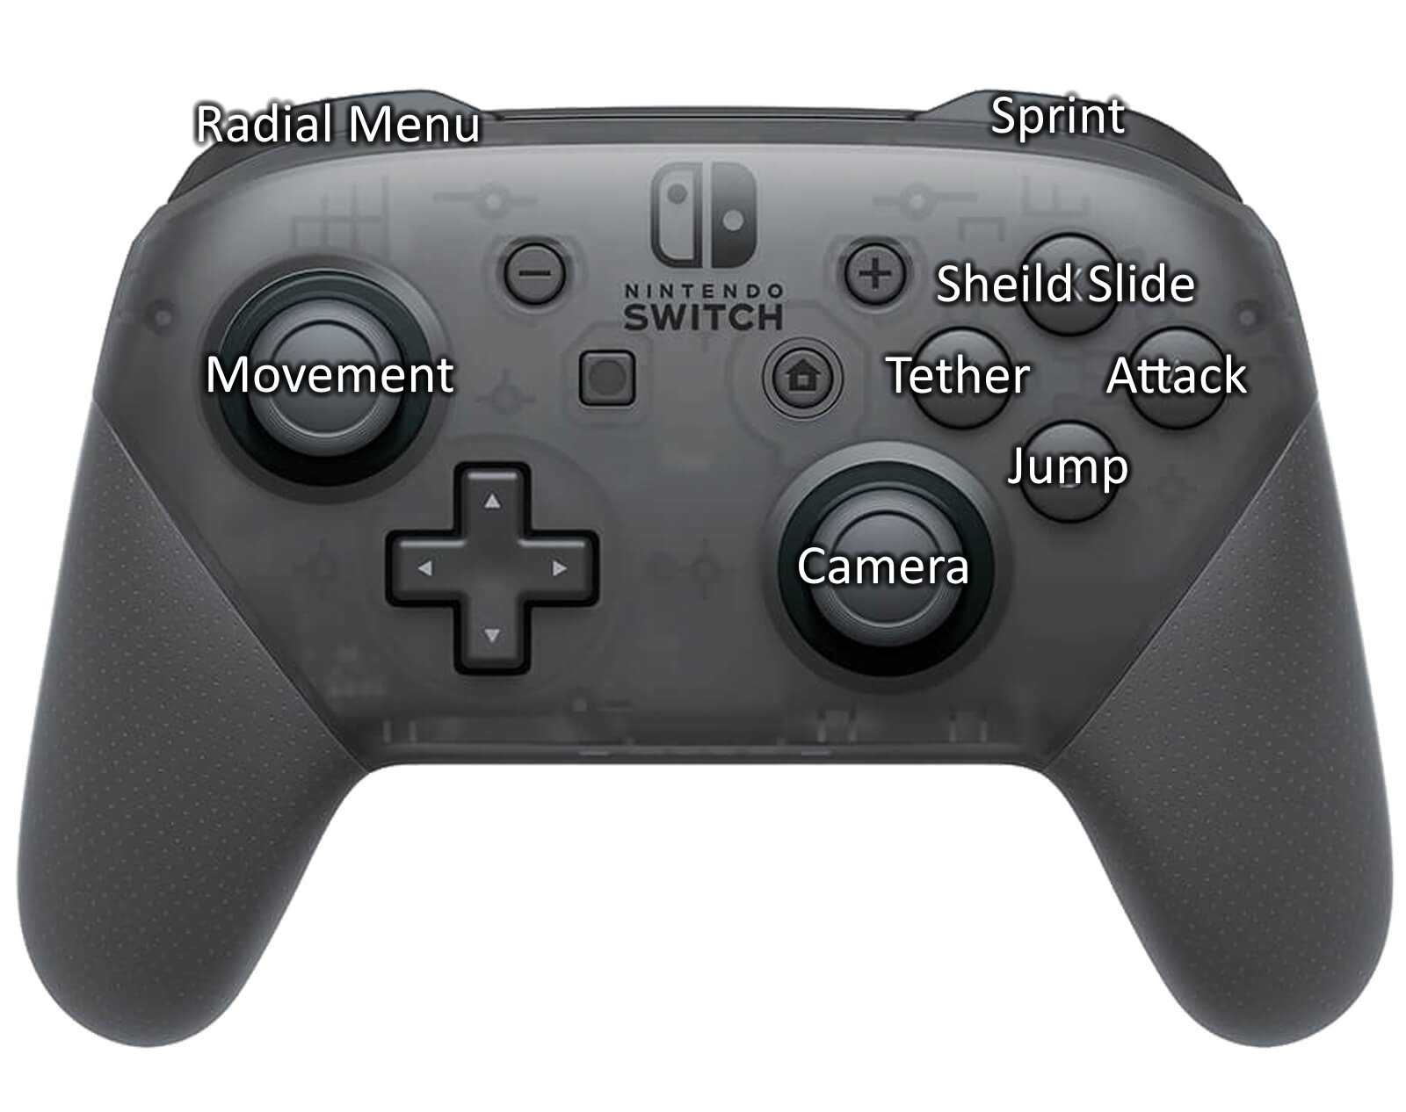

When designing the control scheme of the game we considered the fact that all the buttons on the right side of the controller, including the right stick too, can only be pressed one at a time. This is also true for the bumper with their respective triggers, and the left stick with the d-pad. As such the team concluded that these controls would work best for the game.

**Default Bindings:**

**B – Jump.**

We put jump on ‘**B**’ as most people recognise this as the jump button due to most games using it as such.

**A – Attack.**

We placed attack on ‘**A**’ due to it being a natural resting position for the thumb when not pressing any other button, this is due to the attack button use requiring the fastest time to press.

**X – Shield slide.**

We placed the shield slide on ‘**X**’ as the team decided it would be one of the more commonly used abilities and as such is placed closer to the thumbs resting position.

**Y – Tether.**

we placed grapple on ‘**Y**’ as we felt it will be the one of the lesser used abilities out of the abilities on the right-side buttons, due to it mainly being tied to situational uses.

**Left stick – Player movement.**

We chose the ‘**left stick**’ pretty much due to it being the go-to movement button on almost all games, changing this would confuse the player more than anything.

**Right stick – Camera movement.**

Similarly, to the left stick, we chose the ‘**right stick**’ due to its frequent use for the same or similar functionality in other games.

**Left trigger – Open radial quick select.**

We felt the ‘**left trigger**’ was the most natural place for the radial menu, this is due to it being commonly used for similar purposes in many other games. The player would use either the right or left stick to hover over a weapon and release the left trigger to select it.

**Right trigger – Sprint.**

We placed sprint on the ‘**right trigger**’ due to the player using it in conjunction with the other abilities also on the right side of the controller, allowing them to more comfortably press multiple buttons at once.

**Non-Bound movements:**

**Double Jump.**

This is performed once by pressing jump again while airborne.

**Glide.**

This is performed by the player holding down the jump button while airborne rather than releasing it. This can be combined with the double jump for extra distance.

**Ride Zipwire.**

This is performed by jump while within the range of a zipwire.

**Game Settings**

Like most games we plan on allowing the player to alter specific attributes of the game to allow for a more comfortable play style. We hope to allow all buttons to be rebound to whatever the player feels comfortable with along side a few other settings to either help performance or alter the audio of the game.

**Control binding options**:

Allow the player to customise the button bindings.

**Controller type:**

Change the name of the buttons based on specific controllers, i.e. switch controller

**Volume:**

Variable master volume, sound effects, background music, ambience.

**Video settings:**

Decrease shadow and lighting quality, texture quality, window resolution, Fullscreen or windowed, Brightness ect.

Volume – master, sound effects, background music, ambience

Video settings – shadows, lighting, texture quality, window resolution, Fullscreen or windowed, Brightness

Control binding options – allow the player to set all the game bindings

Default controls (button names based on switch controller):